**Exercise 1:**

Consider the following tables

The following tables describe the authors’ information and the information regarding the learning materials they are supposed to write. An author can write learning material for either degree or Diploma, but not both. An author can, however, write a learning material for different courses in the same stream but they cannot write for different streams. Degree and Diploma curricula may contain same subject but they differ in the level of treatment. Note that the different authors can have the same names but they have unique SSN.

Author-Learning Material

|  |  |  |  |
| --- | --- | --- | --- |
| Author Name | Course_Title | Stream | Level |
| Smith | Data Structures | Computer Science | Degree |
| Arun | Measurement Techniques | Civil Engineering | Degree |
| John | Engineering Mathematics | Engineering | Diploma |
| Smith | Software Engineering | Computer Science | Degree |

Author

|  |  |  |  |
| --- | --- | --- | --- |
| Author_SSN | Author_Name | Author_DOB | Author_Address |
| 501 | Smith | 4/12/1956 |  |
| 634 | Arun | 5/4/1961 |  |
| 122 | John | 23/1/1970 |  |
| 778 | Paul | 30/5/1967 |  |

1. Select a primary key for the relation Author-LearningMaterial.
2. Does the above database violates domain integrity constraint? State the reason for your answer.
3. Is author name foreign key in any one of the above relations? Why?
4. Redesign the above tables so that a reference can be made from Author_LearningMaterial relation to Author relation.

**Exercise 2.**

Consider the following table:

FILM

|  |  |  |  |  |  |  |  |
| --- | --- | --- | --- | --- | --- | --- | --- |
| **Film Number** | **Film Name** | **Director Number** | **Director_**  **name** | **Actor**  **_No** | **Actor_**  **name** | **Role** | **Time On_**  **Screen** |
| F100  F100  F100  F109  F109 | Happy Days  Happy Days  Happy Days  Snake Bite  Snake Bite | D101  D101    D101  D706  D706 | Jim Alan  Jim Alan  Jim Alan  Sue Ramsey  Sue Ramsey | A102  A122  A102  A156  A122 | Sheila T  Peter Walt  Sheila T  S Donald  Peter Walt | Jean Simson  Tom Kinder  Silvia  Tim Rosy  Archie Bold | 15.45  25.38  22.56  19.56  10.44 |

The above table provides information regarding films such as who directed a particular film, who are all the actors, what are their roles and in that role how much time they appear on the screen. The business rules for the above database are as follows: One actor can act in many films and in a film one actor can act in many roles. Many actors can act in one film but only one director directs one film. One director can direct many films.

1. Identify the candidate keys for the above table and choose a primary key .
2. Assume and write down some domain constraint for the above table.
3. What are the disadvantages of using the above table?

Now consider the following tables:

FILM_DIRECTOR

|  |  |  |
| --- | --- | --- |
| Film Number | Film Name | Director Number |

DIRECTOR

|  |  |
| --- | --- |
| Director Number | Director Name |

ACTOR

|  |  |
| --- | --- |
| Actor Number | Actor Name |

ROLE_IN_FILM

|  |  |  |  |
| --- | --- | --- | --- |
| Film Number | Actor Number | Role | Time_On_Screen |

1. Identify the primary key and foreign key in each of the above relations.
2. Write down the referential integrity constraints.
3. What are the advantages of using this database design over the previous design where all the information are stored in a single table.
4. Mention a situation when the previous design is desirable.

**Exercise 3**

Consider the following tables (The attributes given in bold letters indicate primary key).

Staff

|  |  |  |  |
| --- | --- | --- | --- |
| **Staff Number** | Staff Name | Department | Skill Code |

Skill

|  |  |  |
| --- | --- | --- |
| **Skill_Code** | Skill description | ChargeOutRate |

Project

|  |  |  |  |  |
| --- | --- | --- | --- | --- |
| P**roject_Number** | Start_Date | End_Date | Budget | ProjectManager_StaffNo |

Booking

|  |  |  |  |
| --- | --- | --- | --- |
| **Staff_Number** | **Project_Number** | Date_Worked_On | Time_Worked_On |

Where:

The table Staff contains staff details. Skill Code in this table is the foreign key that has reference to the table Skill. The table Skill contains descriptions of skill codes (e.g. Programmer, Analyst, Manager, etc.) and the charge out rate per hour for that skill.

The charge out rate has minimum value of Rs 100 and the maximum value of Rs 1000 depending on the experience of the staff. The table Project contains project details. ProjecManager_StaffNo is a foreign key that has a reference to the table Staff and the budget value should not be assigned NULL. The table Booking contains details of the date and the number of hours that a member of staff worked on a project. Generally most of the staff members work 3 hours per day for a project.

1. What are the domain constraints that can be captured from the above information.
2. Mention the referential integrity constraints that can be captured from the above tables.
3. Can a foreign key take a null value? If your answer is no provide suitable example. Can you provide the above database as an example?

**Exercise 4.**

Convert the following E_R diagrams to tables.

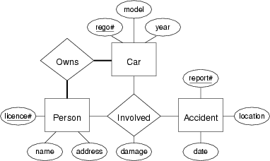

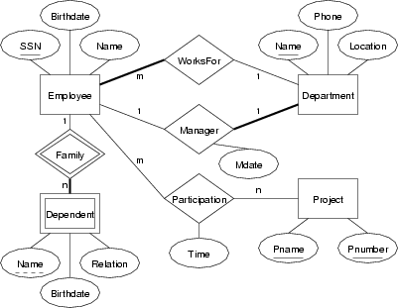

­­­ii) ert the following E_R diagrams to tables.